**InternHub**

**Group Members Details:**

**Roll No & Name of Students:**16010122106 - Ninad Marathe   
16010122109 - Aakriti Mehta   
16010122110 - Aayush Mehta

**Objective:**  
The objective of this project is to create a user-friendly platform for job seekers and employers, enabling seamless interactions for job postings, applications, and hiring processes. The platform aims to facilitate easy account management and enhance the user experience for both clients (companies) and applicants (freelancers/interns).

**Work distribution (functionality wise):**

User Interface Design and UX Research (Figma) - Ninad, Aakriti, Aayush  
Front-end of the website - Ninad, Aakriti, Aayush  
Back-end of the website - Aakriti , Aayush

**Database:**

**Type: NoSQL Database (MongoDB)**

#### 1. Users Collection

* Purpose: Store user information.
* Fields:
  + userId: ObjectId (Primary Key)
  + name: String
  + email: String (Unique)
  + passwordHash: String
  + accountType: String (e.g., "Client/Company", "Freelancer/Intern")

#### 2. Jobs Collection

* Purpose: Store job postings.
* Fields:
  + jobId: ObjectId (Primary Key)
  + title: String (Required)
  + description: String
  + location: String (Required)
  + salary: Number (Required)
  + user: ObjectId (Reference to Users collection)
  + company: String (Reference to Recruiter collection)
  + date: Date (Default: current date)
  + applicants: Array of Objects:
    - applicant: ObjectId (Reference to Users collection)
    - resume: Object (Optional)
      * fileId: ObjectId (Reference to file storage)
    - status: String (Default: "Pending", Enum: ["Accepted", "Rejected"])
  + status: String (Enum: ["Listing", "Closed", "Actively Hiring"], Default: "Listing")

#### 3. Applications Collection

* Purpose: Store job applications.
* Fields:
  + applicationId: ObjectId (Primary Key)
  + user: ObjectId (Reference to Users collection)
  + job: ObjectId (Reference to Jobs collection)
  + company: String (Reference to Jobs collection)
  + status: String (Default: "Pending")
  + message: String (Default: "")
  + resume: ObjectId (Reference to Users collection)

#### 4. Recruiter Profiles Collection

* Purpose: Store information about recruiters and their companies.
* Fields:
  + profileId: ObjectId (Primary Key)
  + user: ObjectId (Reference to Users collection)
  + company: String
  + website: String
  + location: String
  + description: String
  + social: Object (Optional)
    - youtube: String
    - twitter: String
    - facebook: String
    - linkedin: String
    - instagram: String
  + date: Date (Default: current date)

#### 5. Intern Profiles Collection

* Purpose: Store profiles for freelancers/interns.
* Fields:
  + profileId: ObjectId (Primary Key)
  + user: ObjectId (Reference to Users collection)
  + resume: Object (Optional)
    - filename: String
    - fileId: ObjectId (Reference to file storage)
    - contentType: String
    - uploadDate: Date (Default: current date)
  + website: String
  + location: String
  + description: String
  + skills: Array of Strings (Required)
  + bio: String
  + githubusername: String
  + experience: Array of Objects:
    - title: String (Required)
    - company: String (Required)
    - location: String
    - from: Date (Required)
    - to: Date
    - current: Boolean (Default: false)
    - description: String
  + education: Array of Objects:
    - school: String (Required)
    - degree: String (Required)
    - fieldofstudy: String (Required)
    - from: Date (Required)
    - to: Date
    - current: Boolean (Default: false)
    - description: String
  + date: Date (Default: current date)

**Screenshot:**

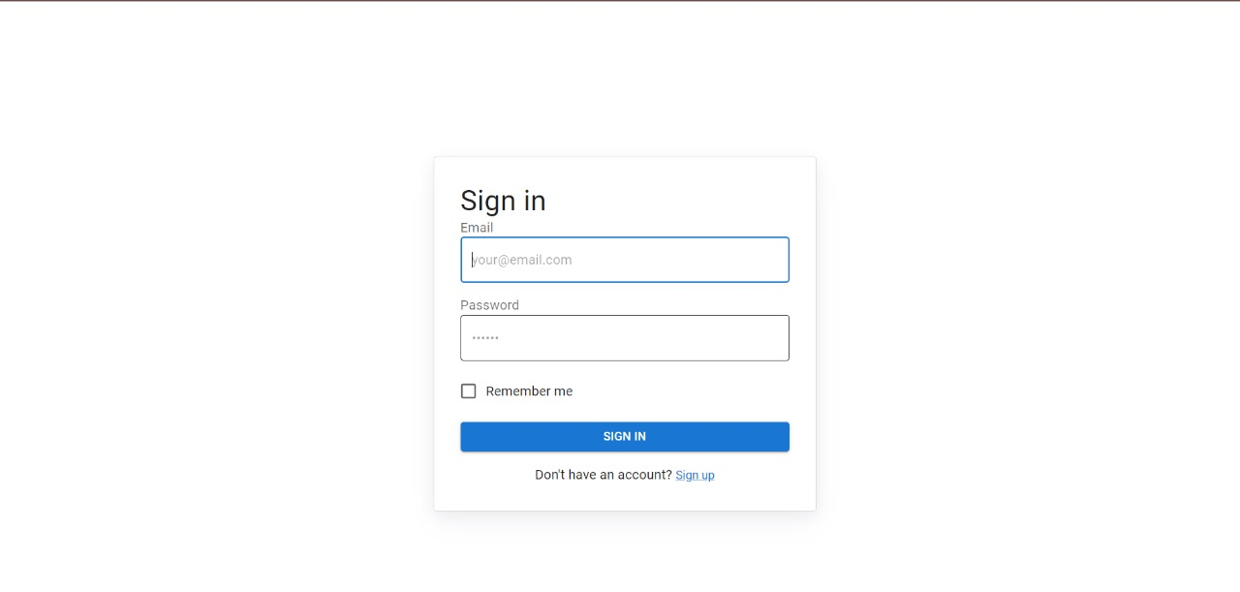

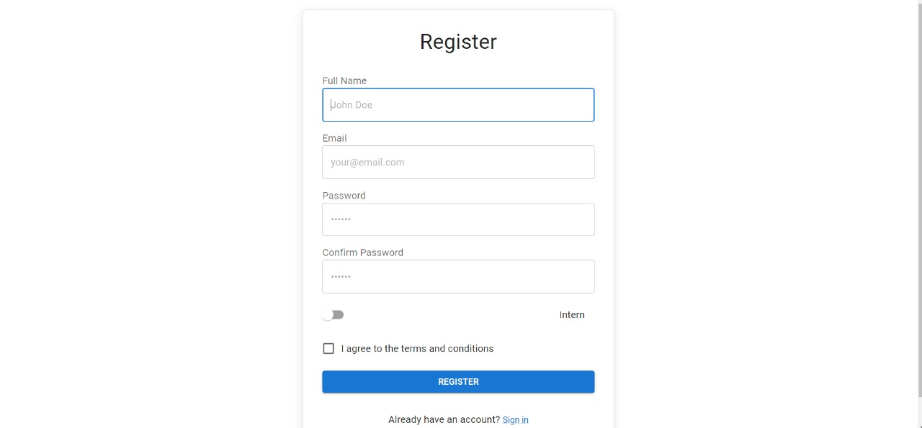

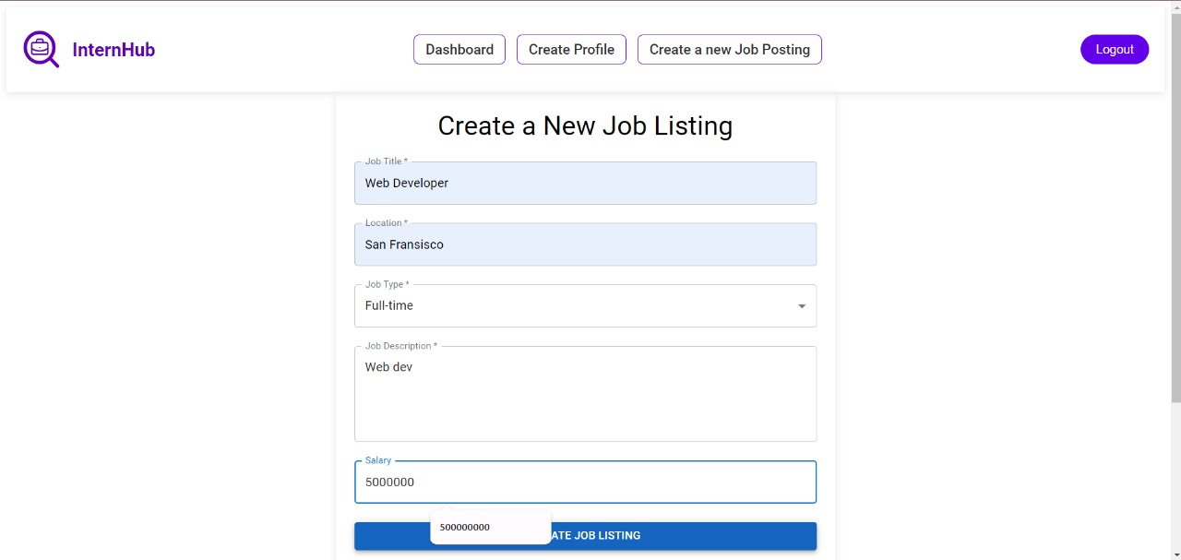

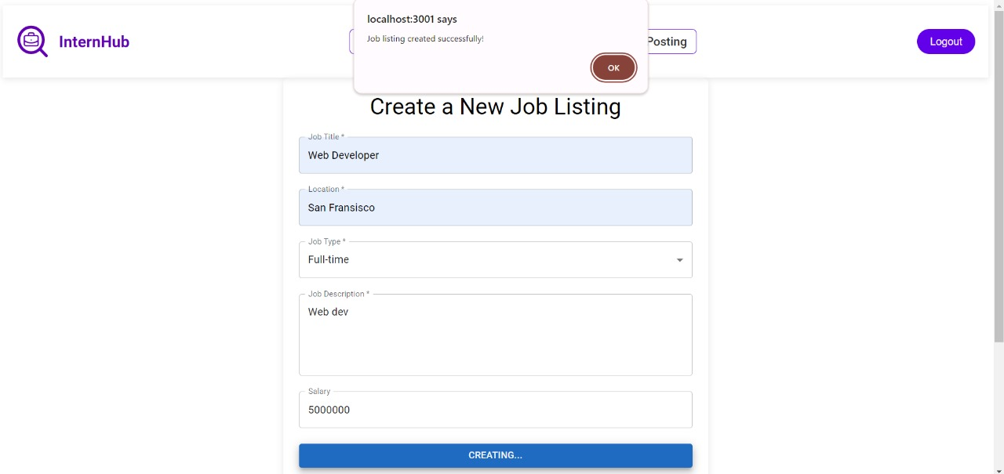

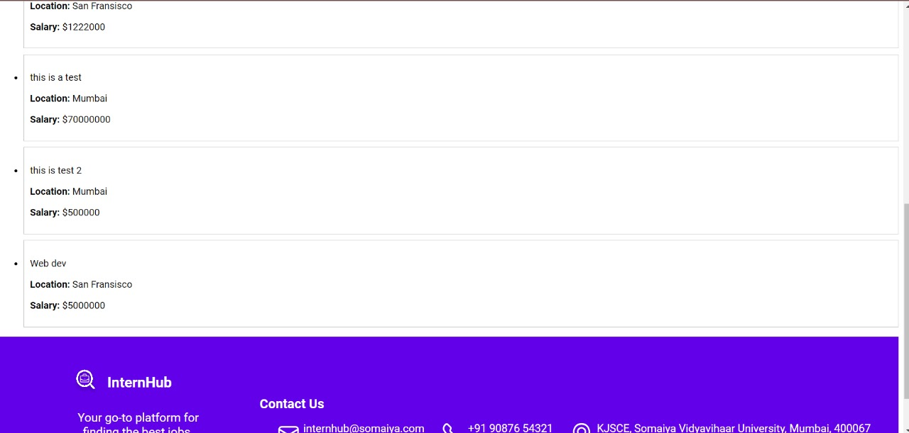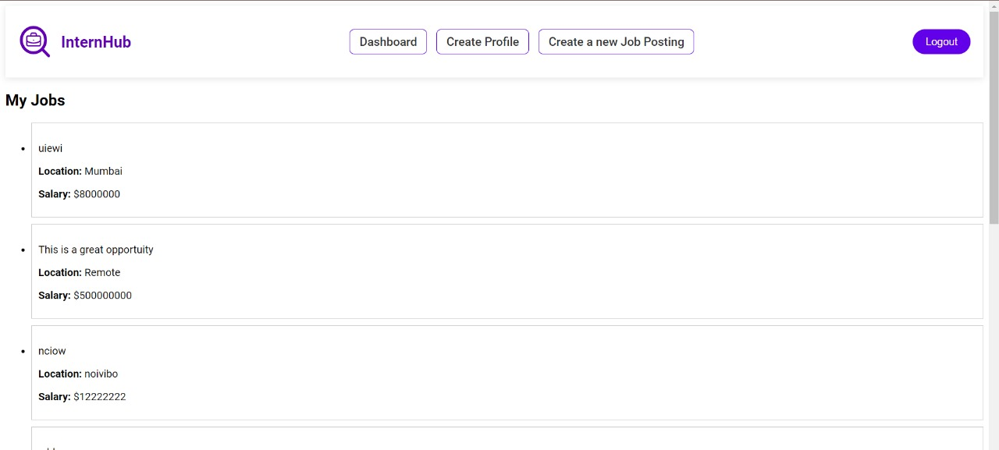

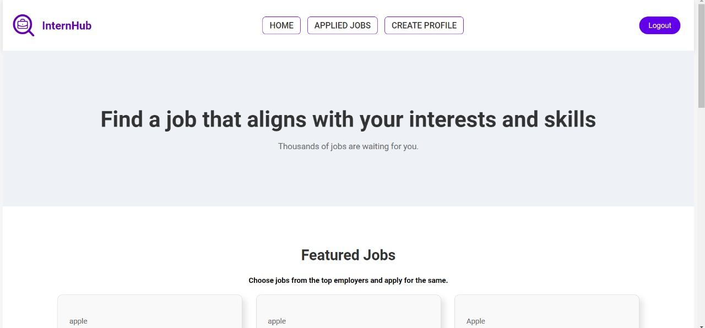

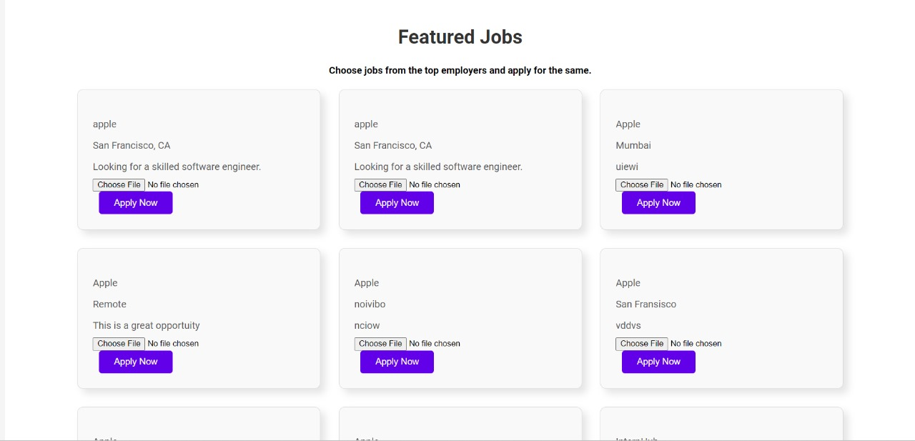

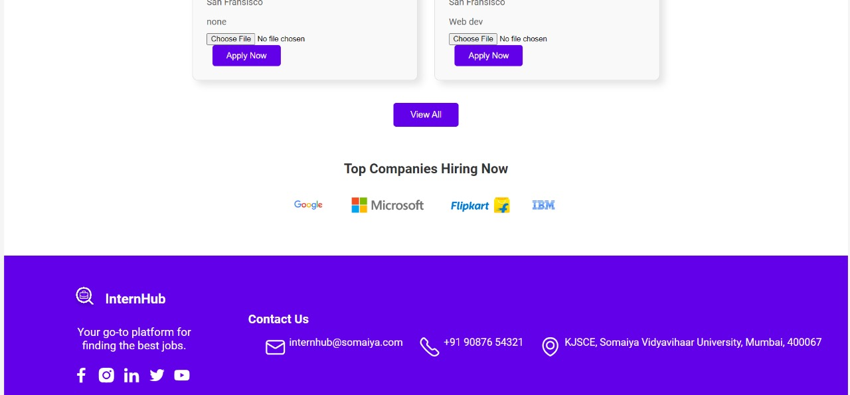

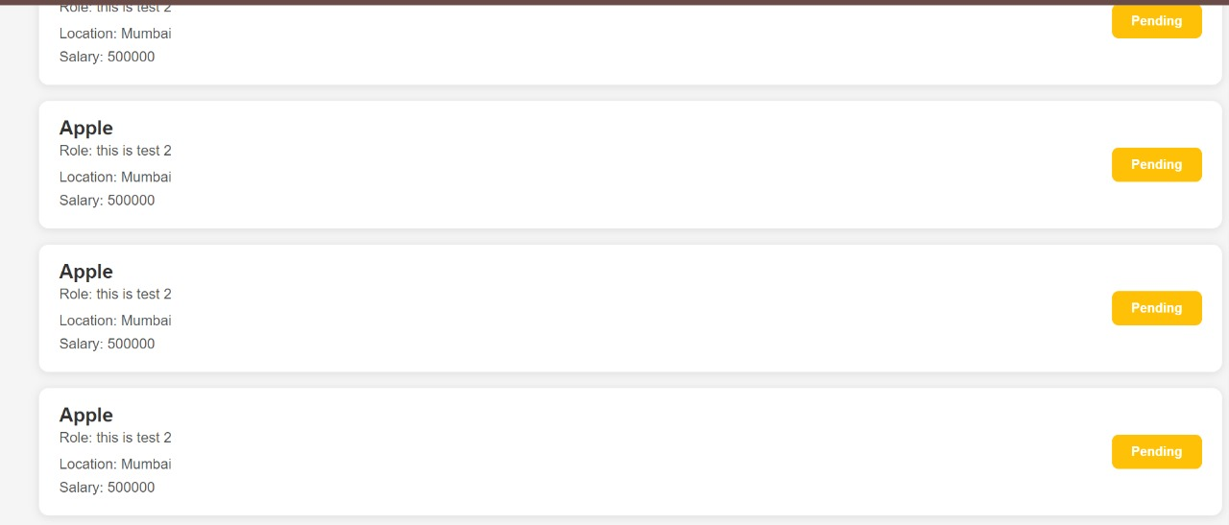

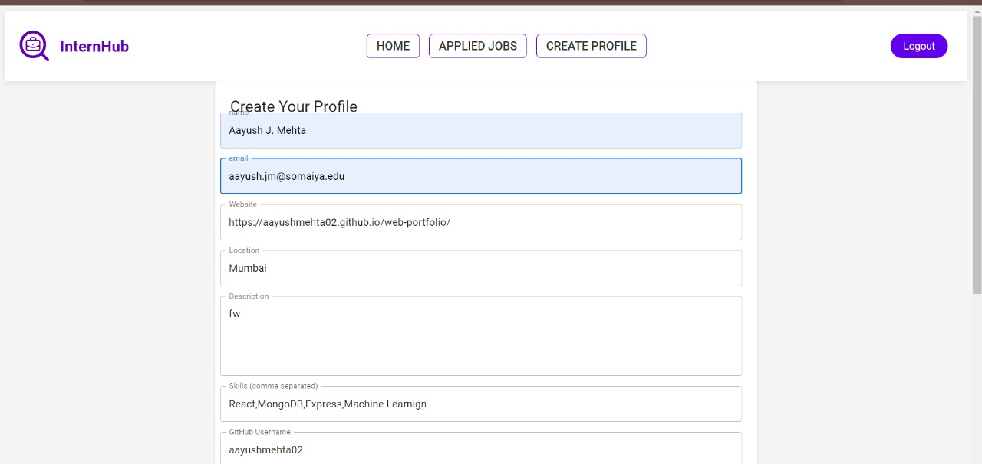

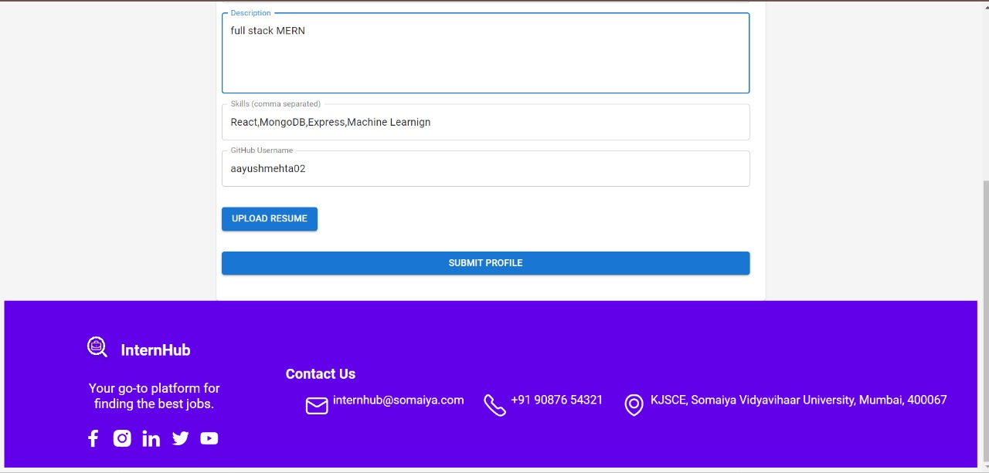

**Tech Stack Used :**

* **FrontEnd :** React JS , MUI
* **Database :** MONGO DB , Node Js

**Features implemented:**

The features implemented in the project likely include:

1. User authentication: There is functionality for users to sign up, log in, and manage their accounts on the platform.
2. Job posting: The system allows employers or users to submit new job postings via a form.
3. User profile management: Users can create or update their profiles, possibly including personal details, professional background, or preferences.
4. Job listing and browsing: There is a feature where users can view or browse available jobs or job-related content.
5. File upload: Functionality to upload files, potentially for resumes, cover letters, or other job-related documents.

**Technical Issues Encountered and Solved:**

Git Pull Issue:

* Problem: There was an issue during the git pull process, likely due to merge conflicts or synchronization problems between team members.
* Solution: The team resolved this by manually merging conflicts, ensuring that all team members pulled the latest changes before committing new work, and implementing a better branching strategy to avoid conflicts in the future.

Image Loading Issue:

* Problem: Images were not loading correctly, possibly due to incorrect file paths, broken links, or issues with the image hosting service.
* Solution: This issue was fixed by verifying and correcting image paths, ensuring that images were properly uploaded to the correct directories or server, and optimizing the image loading process (e.g., using lazy loading techniques to improve performance).

MongoDB Connection Issue:

* Problem: The application encountered issues connecting to MongoDB, possibly due to incorrect connection strings, authentication problems, or server downtime.
* Solution: The problem was resolved by checking the MongoDB URI, ensuring correct server credentials were in place, and verifying that the MongoDB server was running without issues. Retry logic and connection pooling were implemented to improve database connection stability**.**

**The future scope of the project is :**

* Integrating advanced filtering options for job searches to improve user experience.
* Implementing a rating and review system for employers and applicants to enhance trust.
* Adding analytics features for employers to track job performance and applicant engagement.
* Developing a mobile application to increase accessibility and user engagement.
* Exploring AI-driven features for personalized job recommendations based on user profiles and activity.

(Attach the Read Me File for your project execution)